AI ASSISTING CODING ASSIGNMENT
Shahrukh Syed
2303A510i1
TASK 1
Question 1: Zero-Shot Prompting (Palindrome Number Program)
Write a zero-shot prompt (without providing any examples) to generate
a Python function that checks whether a given number is a palindrome.
Task:
• Record the AI-generated code.
• Test the code with multiple inputs.
• Identify any logical errors or missing edge-case handling.
- Prompt
- write a program to find whether a given number is palindrome or not user defined function.

- # Convert the number to string to check for palindrome

- #print the result

Code:
#write a programe to find whether a given number is palindrome or not user defined function.
def is_palindrome(number):
# Convert the number to string to check for palindrome
str_num = str(number)
# Check if the string is the same forwards and backwards without using slicing
for i in range(len(str_num) // 2):
if str_num[i] != str_num[len(str_num) - 1 - i]:
return False
# it is a palindrome or not
return True
#print the result
num = int(input("Enter a number: "))
if is_palindrome(num):
print(f"{num} is a palindrome.")
else:
print(f"{num} is not a palindrome.") 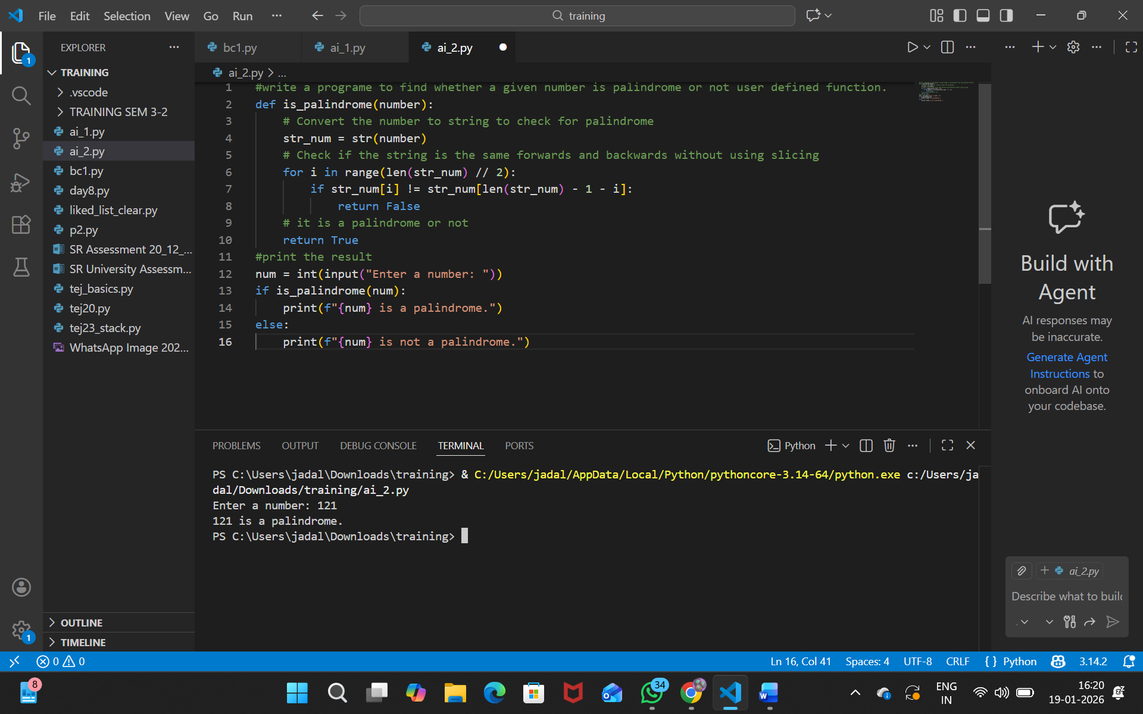

TASK 2
uestion 2: One-Shot Prompting (Factorial Calculation)
Write a one-shot prompt by providing one input-output example and
ask the AI to generate a Python function to compute the factorial of a
given number.
Example:
Input: 5 → Output: 120
Task:
• Compare the generated code with a zero-shot solution.
• Examine improvements in clarity and correctness.

PROMPT
#write a factorial program using user defined function.
# Initialize result to 1
# Get user input
# Multiply result by each number from 1 to n
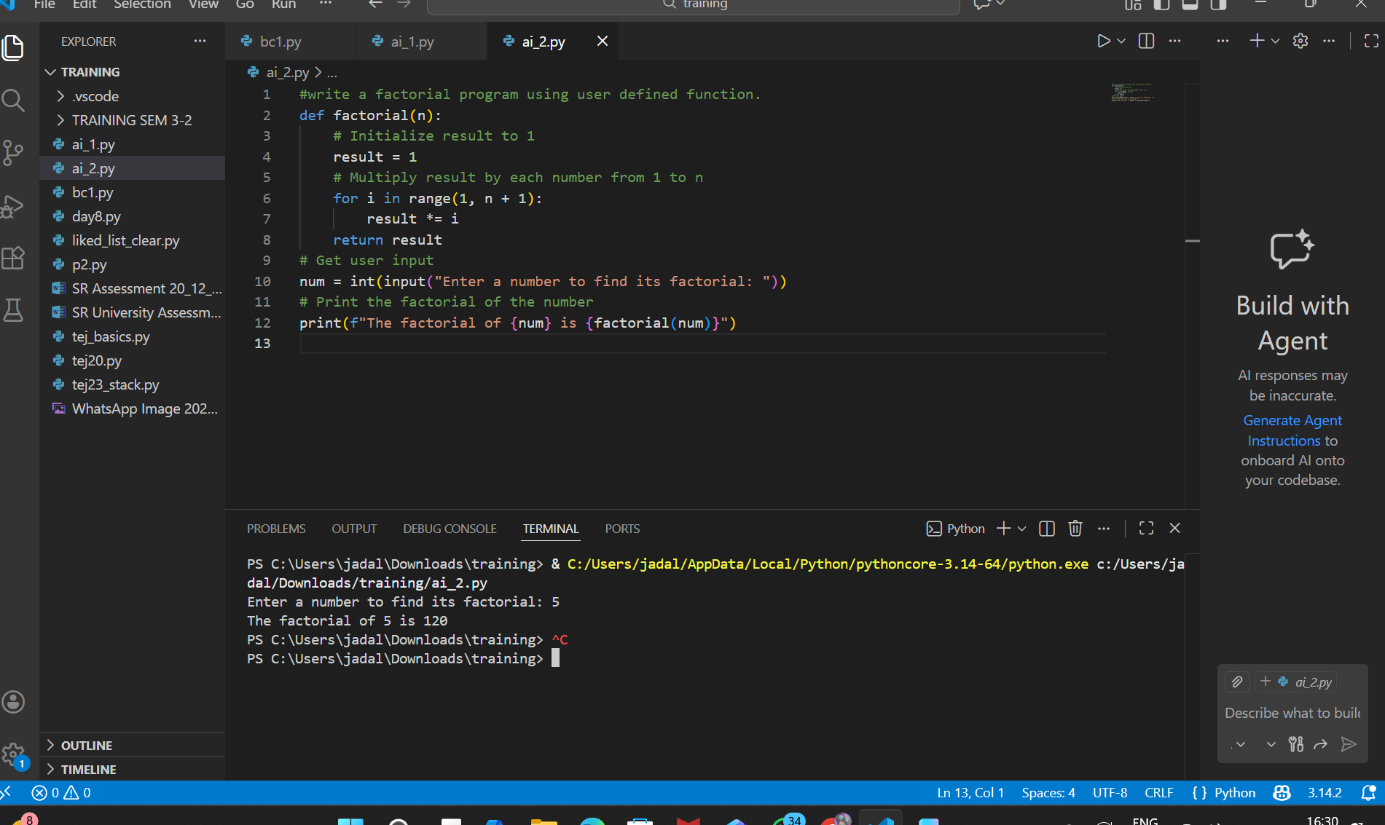

Task 3
Question 3: Few-Shot Prompting (Armstrong Number Check)
Write a few-shot prompt by providing multiple input-output examples
to guide the AI in generating a Python function to check whether a
given number is an Armstrong number.
Examples:
• Input: 153 → Output: Armstrong Number
• Input: 370 → Output: Armstrong Number
• Input: 123 → Output: Not an Armstrong Number
Task:
• Analyze how multiple examples influence code structure and
accuracy.
• Test the function with boundary values and invalid inputs
Prompt
#write a program to find armstrong number check using user defined function.
# Convert the number to string to process each digit
# Check if the sum of powers is equal to the original number
# Get user input

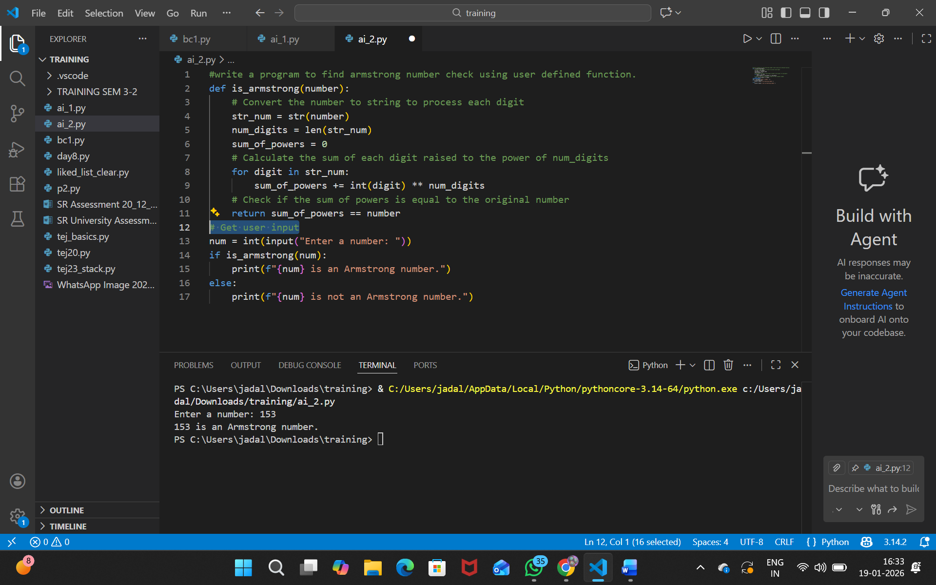
Task 4
Question 4: Context-Managed Prompting (Optimized Number
Classification)
Design a context-managed prompt with clear instructions and
constraints to generate an optimized Python program that classifies a
number as prime, composite, or neither.
Task:
• Ensure proper input validation.
• Optimize the logic for efficiency.
• Compare the output with earlier prompting strategies.
PROMPT
#write a program to find whether agiven number check prime or composite or neither using user defined function.
# Get user input
#check prime number or not

#write a program to find whether agiven number check prime or composite or neither using user defined function.
def check_prime_composite(number):
if number <= 1:
return "neither prime nor composite"
for i in range(2, int(number**0.5) + 1):
if number % i == 0:
return "composite"
return "prime"
# Get user input
num = int(input("Enter a number: "))
result = check_prime_composite(num)
print(f"{num} is {result}.")
#check prime number or not
def is_prime(number):
if number <= 1:
return False
for i in range(2, int(number**0.5) + 1):
if number % i == 0:
return False
return True
# Get user input
num = int(input("Enter a number to check if it's prime: "))
if is_prime(num):
print(f"{num} is a prime number.")
else:
print(f"{num} is not a prime number.")
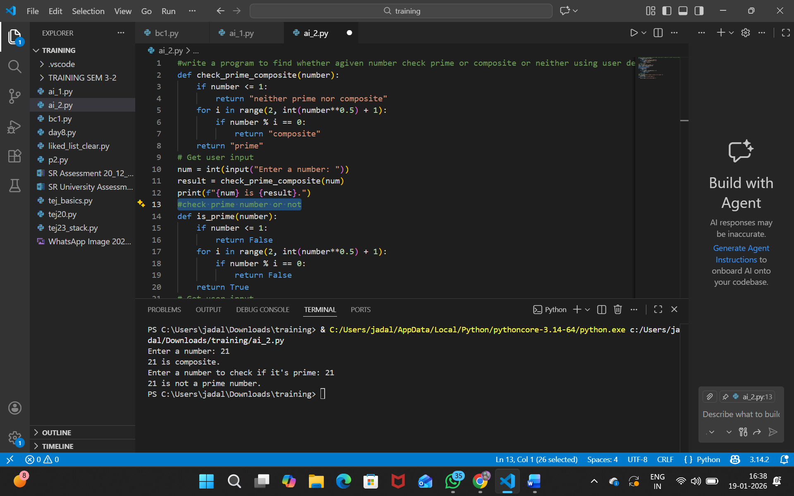
Task 5
Question 5: Zero-Shot Prompting (Perfect Number Check)
Write a zero-shot prompt (without providing any examples) to
generate a Python function that checks whether a given number is a
perfect number.
Task:
• Record the AI-generated code.
• Test the program with multiple inputs.
• Identify any missing conditions or inefficiencies in the logic
PROMPT
#write a program to check whether a given number is perfect number or not using user defined function.
# Initialize sum of divisors
# A perfect number is equal to the sum of its proper divisors
# Get user input
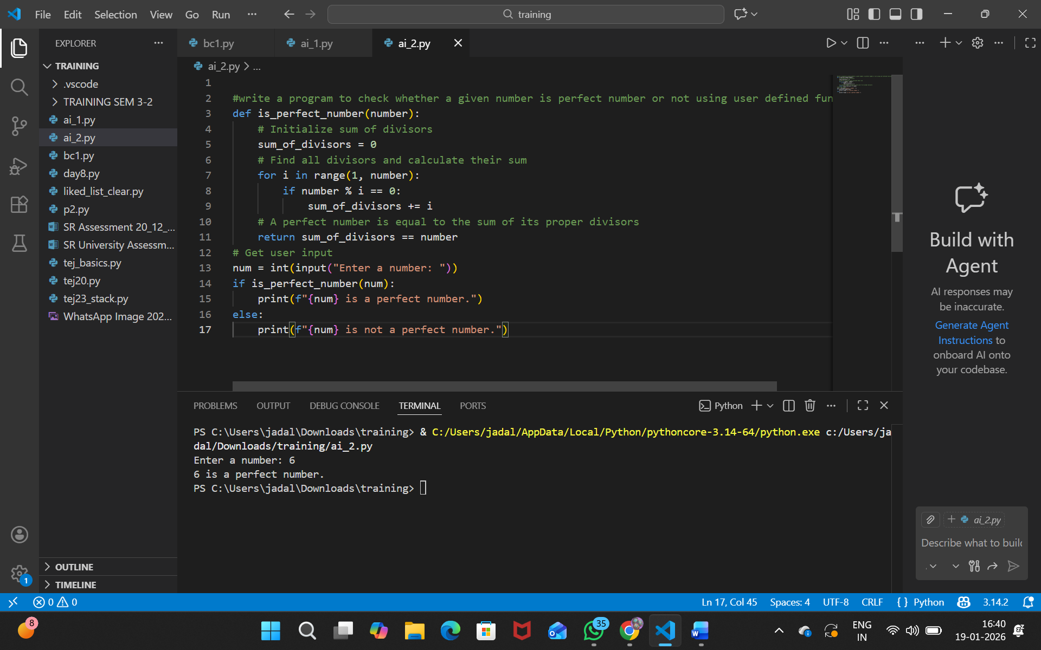
TASK 6
Question 6: Few-Shot Prompting (Even or Odd Classification with
Validation)
Write a few-shot prompt by providing multiple input-output
examples to guide the AI in generating a Python program that
determines whether a given number is even or odd, including proper
input validation.
Examples:
• Input: 8 → Output: Even
• Input: 15 → Output: Odd
• Input: 0 → Output: Even
Task:
• Analyze how examples improve input handling and output
clarity.
• Test the program with negative numbers and non-integer inputs
Prompt
#write a grogram to check the ever or odd validation using user defined function
# Get user input print even or odd multiple times
